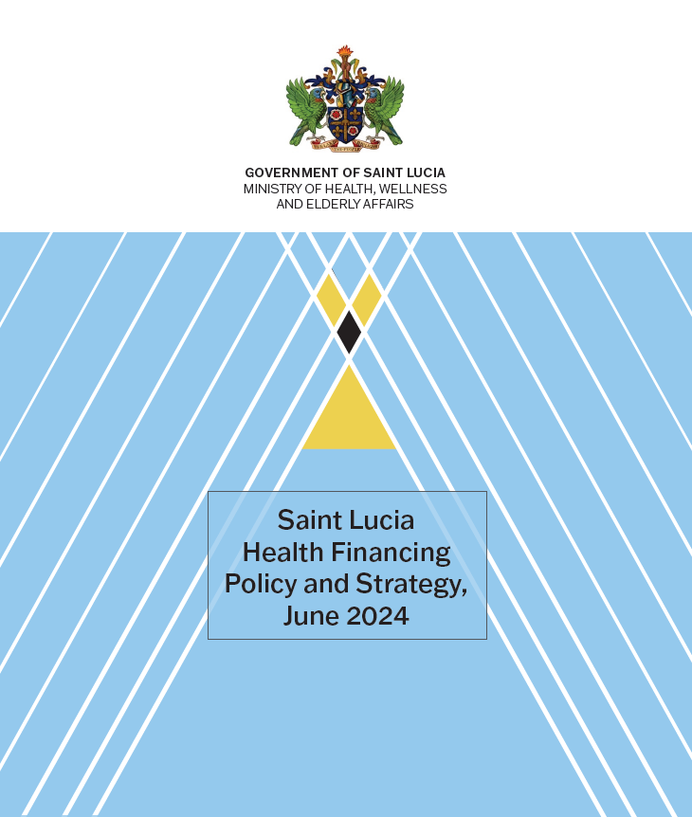

Foreword

The Saint Lucia Ministry of Health, Wellness and Nutrition (MOHWN) recognizes the World Bank’s contributions to the design and implementation of the Universal Health Coverage Health Financing Policy and Strategy. Under the Health Systems Strengthening Project (HSSP), the Ministry worked along with the World Bank to develop the Saint Lucia Health Financing Policy and Strategy (HFPS 2024) through a consultative process, and the Performance Based Financing (PBF) Pilot was implemented in Saint Lucia between August 2023 and October 2025. The Saint Lucia Government through the MOHWN continued its thrust towards attaining a financing mechanism for UHC, hiring the Joint Independent Providers Association (JIPA) to further develop and operationalize UHC finacing. The HFPS and the UHC White Paper informed the National Strategic Plan for Health (2025-2035) and the National Health Compact (2025-2030). These policy and strategy documents jointly guide the Government on the expansion and sustainable financing of UHC.

A Healthier Future for All: Executive Summary of Saint Lucia’s Health Financing Policy and Strategy (2026–2036)
The Ministry of Health, Wellness and Nutrition (MOHWN) is committed to build a stronger, fairer, and more sustainable health system for every person in Saint Lucia. The Health Financing Policy and Strategy (HFPS) guides the path to achieve Universal Health Coverage (UHC): making sure everyone can get the care they need without financial hardship. This plan shifts from funding health facilities based on past budgets to purchasing the most effective services and rewarding quality care. The consultative process led to the following agreements to be pursued.

1. Vision and Purpose
- Guarantee access for all: Every person will be entitled to a defined package of essential health services, starting with primary care.
- Advance equity and solidarity: Care will be based on need, not ability to pay or where you live.
- Protect households from high costs: We will reduce out-of-pocket payments by expanding prepaid and pooled funding.

2. Key Objectives and Priorities
- Strengthen primary health care (PHC): Wellness centers will be the backbone of the system, focusing on prevention, early detection, and management of chronic diseases like diabetes and hypertension.
- Improve financial protection: Shift payments away from the point of service toward sustainable prepayment and pooled funds to reduce out-of-pocket payments.
- Purchase for results: Pay providers for the quality and quantity of services delivered, not just for inputs, to improve efficiency and outcomes, including patient satisfaction.
- Ensure sustainable, equitable financing: Increase health investment over time and allocate funds according to health needs across the country.

3. What Will Change for Citizens
- A Basic Benefit Package (BBP) for all:
  - Phase 1: Free access to services at primary health care centers, including consultations, essential tests, and management of priority conditions.
  - Phase 2 and beyond: Gradual expansion to selected outpatient specialty and hospital services (BBP+).
- Easier access, closer to home: More services delivered at wellness centers to reduce unnecessary hospital visits.
- Better quality care: Providers will be rewarded for meeting performance and quality targets, such as screening rates and treatment adherence.
- Less financial stress: As the package expands, out-of-pocket costs will fall, especially for common and essential services.
- Improved sustainability: Encourage health care seeking early and at the right level of care to reduce costs and improve health outcomes.

4. Major Programs and Interventions
- Strategic purchasing: A national health purchaser operating under the Ministry, will contract public and private providers to deliver the BBP, focusing on value for money.
- Performance-Based Financing (PBF): Providers will be paid based on hitting quality and service volume targets—early rollouts between August 2023 and October 2025 have shown promising results (improved management of NCDs).
- Population-based PHC financing: Wellness centers are funded based on the population they serve, encouraging proactive, community-focused care.

5. Implementation

Phase I (Years 1–2): Strengthening the foundation
  - Focus: Purchase all frontline PHC services for the entire population.
  - Financing: Targeted increases in government health spending; expand and institutionalize performance-based financing.
  - Outcome: Better access and quality at PHC level, creating efficiency gains to support expansion.

Phase II (Years 3–5): Expanding services
  - Focus: Add package of outpatient specialty, outpatient surgery, and additional benefits for inpatient care.
  - Financing: Continued government revenues + prepayment (payroll contribution and insurance), subsidy for the poor and vulnerable
  - Outcome: Consolidate purchasing systems and prepare for broader coverage.

Phase III (Years 6–10): Achieving universal coverage
  - Focus: Expand benefits and significantly reduce out-of-pocket costs.
  - Financing: Further strengthen prepayment mechanisms (e.g., payroll contributions for the formal sector and premiums for the informal sector), with government subsidies for the poor and unemployed.
  - Outcome: Comprehensive, equitable, and financially sustainable coverage for all.

6. Equity, Access, and Quality
- Equity: Funding will be pooled and allocated based on health needs, ensuring fair distribution of resources across regions and population groups.
- Access: Primary care services will be guaranteed nationwide, with progressive expansion to higher-level care.
- Quality: Clear standards, routine measurement, and incentives will drive improvements in patient safety, continuity of care, and user experience.

7. Monitoring Progress
The Ministry will track and publicly report on progress using clear indicators, including:
- Increased use of essential PHC services.
- Improved outcomes for chronic disease management.
- Reduced out-of-pocket spending for households.
- Better patient satisfaction and quality of care.

This data will guide continuous improvements to ensure the strategy stays on track and delivers better health for the nation.

8. Partnerships and Governance
- Strong coordination with the Ministry of Finance to secure sustainable funding and align incentives.
- Contracting with public and private providers to widen access and improve service quality.
- Collaboration with social partners, civil society, and international organizations to support implementation and capacity building.

9. Call to Action
- Citizens: Make full use of your local wellness centers, participate in health promotion activities, and share feedback to help us improve.
- Health providers: Partner with us to deliver high-quality, people-centered care and embrace performance-driven approaches.
- Public and private partners: Work with the Ministry to support financing, service delivery, and innovations that benefit the whole population.


Together, we will build a health system that delivers quality care for life—accessible, affordable, and equitable for every person in Saint Lucia.



Saint Lucia National Health Compact (2025-2030)
The Government of Saint Lucia has committed to UHC as a national development priority and as the central framework for financing, delivering, and regulating healthcare. Cabinet Conclusion 129 of 2022 endorsed the development of a sustainable UHC financing model aimed at reducing out-of-pocket expenditure at the point of care and ensuring equitable access for all citizens.
Building on early reforms, including the World Bank-supported Performance-Based Financing (PBF) pilot (2023-2025) for hypertension and diabetes across 17 primary-care facilities, the Government will incrementally increase domestic finance for health—progressively increasing annual budgetary allocations from general revenue rising from 2.8% to 4% of GDP by 2030—and transition to an integrated, output-based, and strategically purchased financing system ensuring that every citizen can access essential care without financial hardship. PBF will serve as the primary mechanism for UHC implementation at the PHC level.
To this end the government commits to the following:
• Expand fiscal space and improve resource mobilization for health through dedicated health taxation—such as the health and security levy—and by mobilizing domestic and external resources to finance primary health care while progressively reducing household spending.

• Establish and operationalize a Universal Health Coverage Authority (UHCA) as a statutory body responsible for managing health financing and strategic purchasing.

• Implement a national health registration system with a unique identifier and possible health card, ensuring that every citizen and resident is enrolled to access UHC benefits, with priority for poor households, elderly persons, and persons with disabilities. The system will also underpin the shift to
capitation-based PHC financing.

• Reform purchasing through population-based resource allocation, strengthened provider contracting and provider payment design. At the primary care level transition from line-item budgeting to a population-based and output-based financing model that ensures equitable
resource allocation across regions and populations and that rewards performance. A population-based capitation formula with adjusters for quality, vulnerability, and service mix will be developed and applied. Management agreements with primary care facilities will be established, based on testing under the PBF Pilot. For hospitals, output-based payment mechanisms and service level agreements will also be piloted with a focus on results, including quality, patient satisfaction, and efficiency of service delivery.

• Strengthen financial protection through improved purchasing, including by establishing a Health Benefits Package (HBP) defining service entitlements and reimbursement models, and by introducing targeted subsidies or vouchers for vulnerable and low-income groups.

• Establish a Universal Disability Support allowance to cover basic disability-related costs. This would include healthcare coverage, basic income security in the form of cash, and a combination of
in-kind support and services.

• Strengthen access to quality care and improve financial protection by improving the affordability of medicines and diagnostics through strategic purchasing and regional cooperation, including expanded pooled procurement through OECS, CARICOM and other mechanisms, and piloting of price-volume and managed entry agreements for low-volume and high-cost medicines.

• Strengthen health financing data, analysis, and transparency by institutionalizing National Health Accounts (NHA) production and dissemination and establishing a digital Health Financing Dashboard integrating HFPS, PBF, and expenditure data.

The MOHWN is grateful for grant financing from the Korea World Bank Partnership Facility (KWPF) which contributed to the development of the HFPS.
For example, case-based payment such as diagnostic-related groups (DRG) payment, and bundled provider payment, which aims to incentivize optimal health care service production and spending across PHC and hospital levels.

